Chapter 8, Solution 73.

Design a problem, using PSpice, to help other students to better understand source-free RLC circuits.

Although there are many ways to work this problem, this is an example based on a somewhat similar problem worked in the third edition.

Problem

The step response of an RLC circuit is given by

$$\frac{d^{2}i_{L}}{{dt}^{2}}+0.5\frac{di_{L}}{dt}+4i_{L}=0$$

Given that i_{L}(0) = 3 A and v_{C}(0) = 24 V, solve for v_{C}(t) and I_{C}(t).

Solution

- For t < 0, we have the schematic below. When this is saved and simulated, we obtain the initial inductor current and capacitor voltage as

i_{L}(0) = 3 A and v_{c}(0) = 24 V.

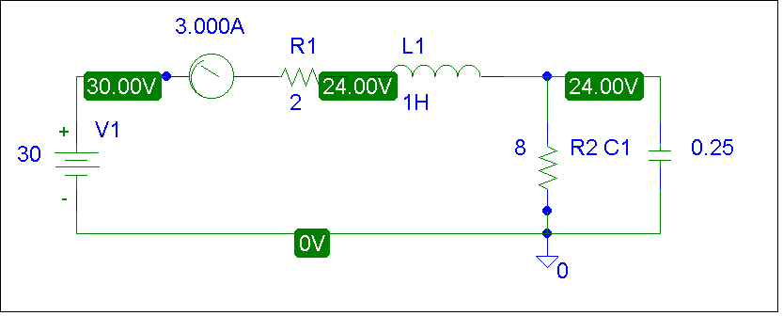

(b) For t > 0, we have the schematic shown below. To display i(t) and v(t), we insert current and voltage markers as shown. The initial inductor current and capacitor voltage are also incorporated. In the Transient box, we set Print Step = 25 ms and the Final Time to 4s. After simulation, we automatically have i_{o}(t) and v_{o}(t) displayed as shown below.
